34.27: 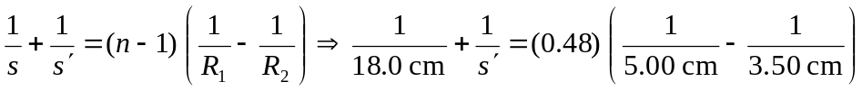
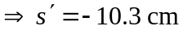(to the left of the lens).

